Deep LearningISE-1

short line

Brijesh kumar (2020BTECS00003)

Prashant Mishra (2020BTECS00004)

Taniya Bhide (2020BTECS00011)

Vishal Chauhan (2020BTECS00090)  
7th April, 2023

# Introduction

1. In this project, we have developed a web-based application that utilizes deep learning to recognize handwritten digits. The application allows users to draw a digit on the screen and the model predicts which digit was drawn.
2. Our project is based on the popular MNIST dataset and uses a deep learning model trained on this dataset to recognize handwritten digits. We have developed a web-based interface that allows users to draw a digit using a mouse or touchpad, and then displays the predicted digit on the screen.
3. Our project is an innovative application of deep learning that can recognize handwritten digits with high accuracy. We have created a web-based platform that allows users to draw digits and receive instant predictions, making it easy and fun to use.

### ScreenShorts

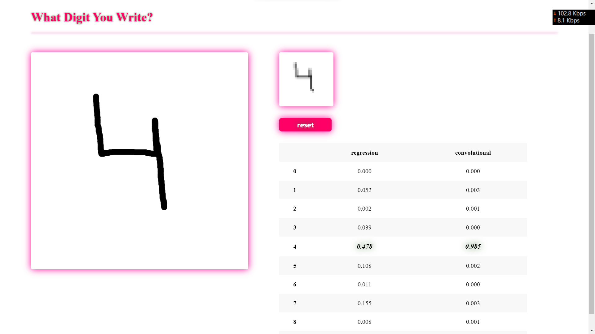

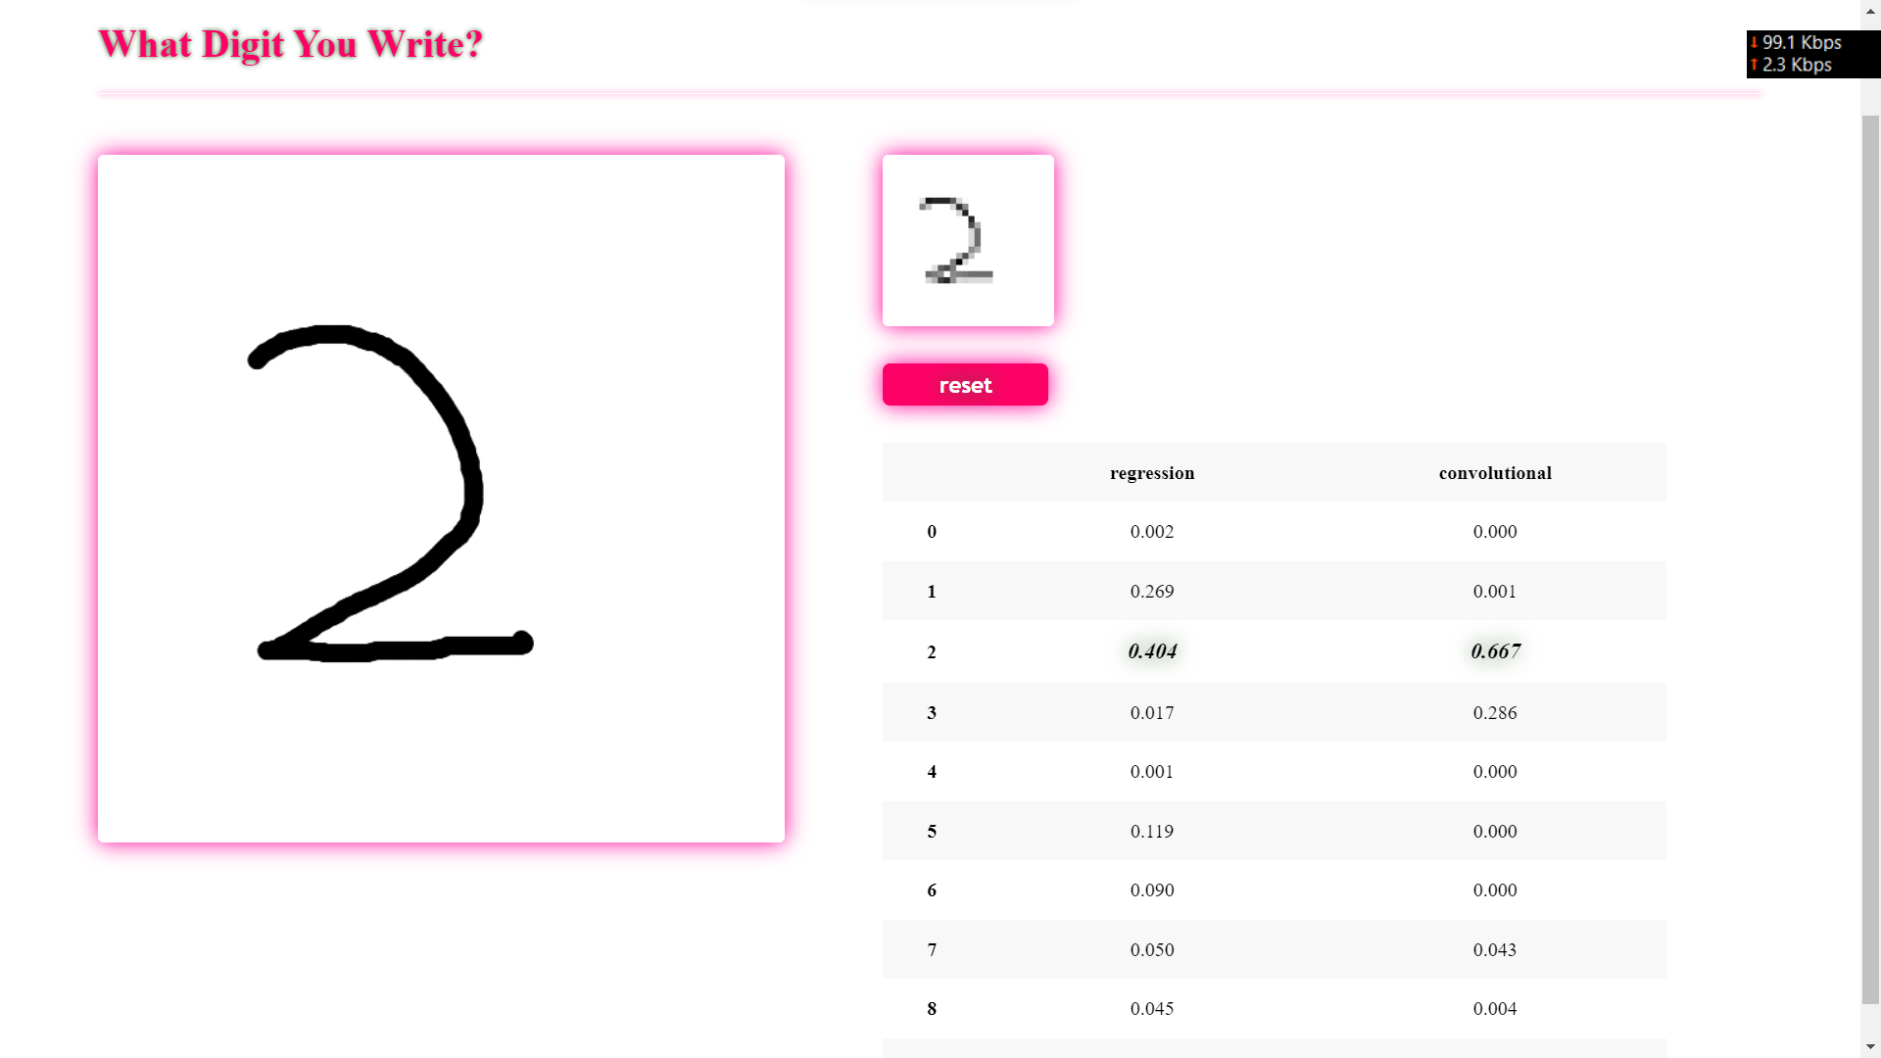

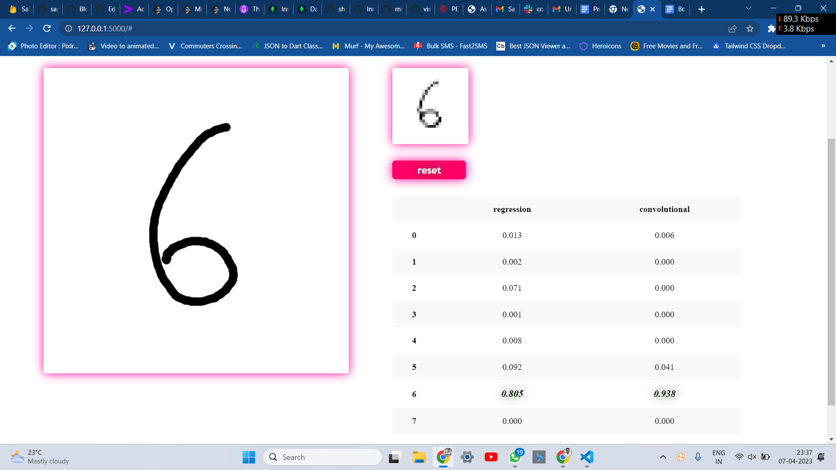

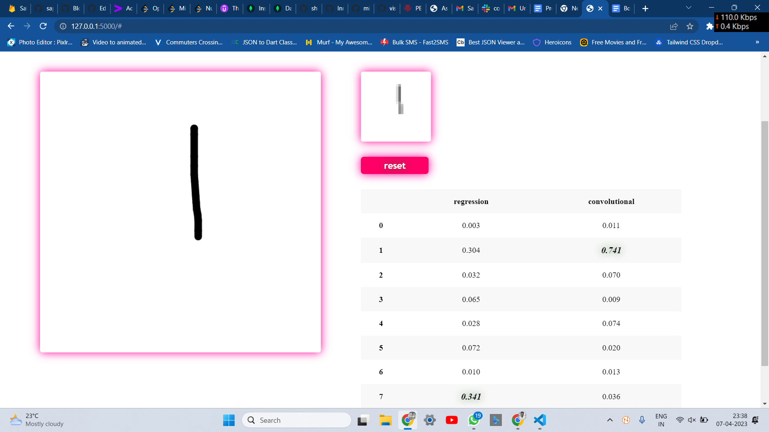

short dash